**Time Series for 7409 items from train_Jan.txt**

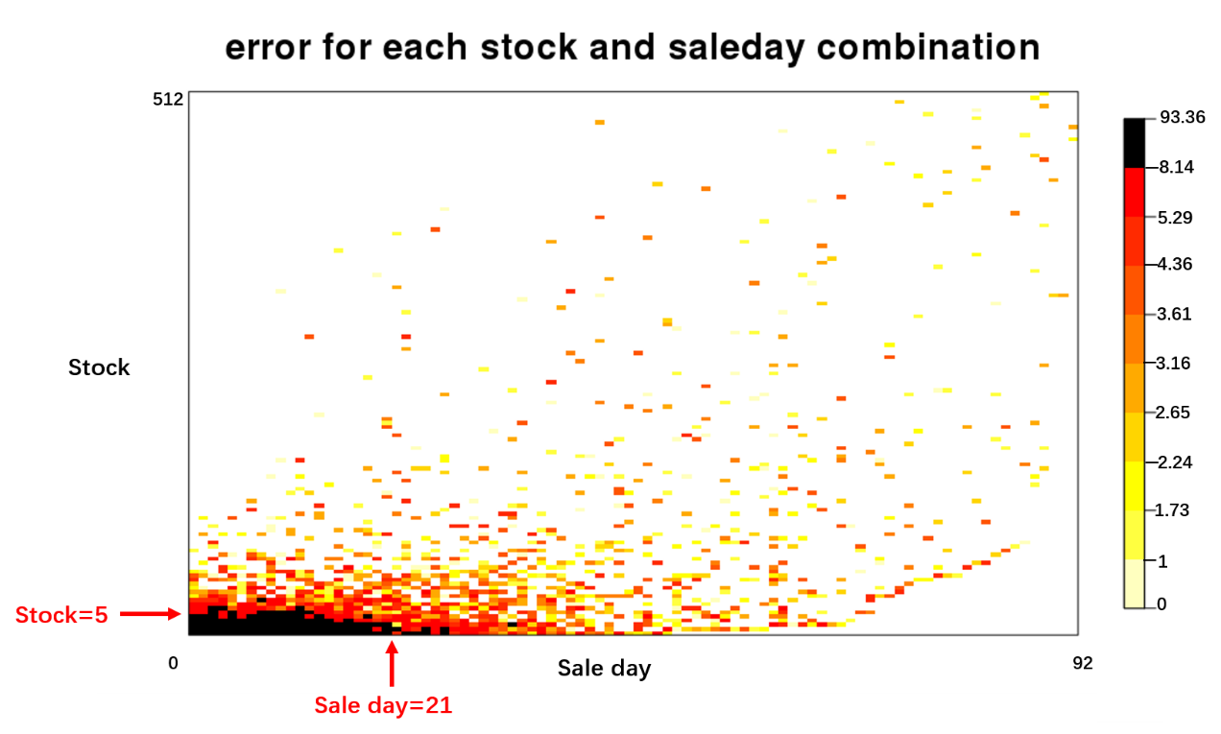

Stock is i from 1 to 512, sale day is j from 1 to 92.

Error for each stock and sale day combination: ERRij=

The distribution for ERRij:

|  |  |  |  |  |  |  |  |  |  |  |
| --- | --- | --- | --- | --- | --- | --- | --- | --- | --- | --- |
| 0% | 10% | 20% | 30% | 40% | 50% | 60% | 70% | 80% | 90% | 100% |
| 0 | 1 | 1.73 | 2.24 | 2.65 | 3.16 | 3.61 | 4.36 | 5.29 | 8.14 | 93.36 |

The black part indicates items with stock>=5 & sale day >=21, which include 5542 items.

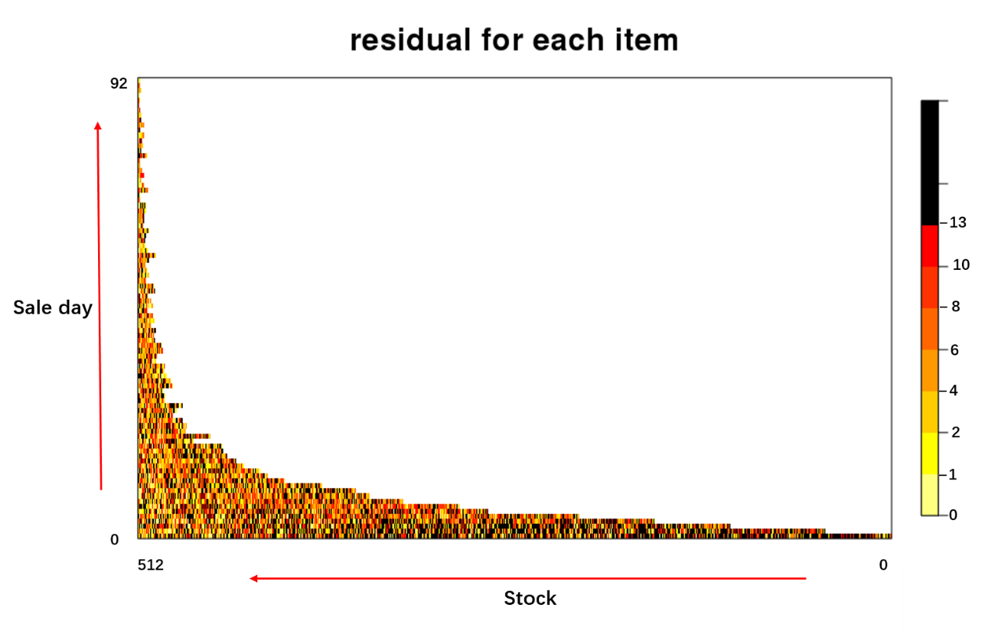

Residual for each item: ${|y}_{ij}-{\hat{y}}_{ij|}$.

Error for random guess is 244.524, the average residual for each item is 8.07.

The distribution for residual of time seriesj:

|  |  |  |  |  |  |  |  |  |  |  |
| --- | --- | --- | --- | --- | --- | --- | --- | --- | --- | --- |
| 0% | 10% | 20% | 30% | 40% | 50% | 60% | 70% | 80% | 90% | 100% |
| 0 | 1 | 2 | 4 | 6 | 8 | 10 | 13 | 16 | 21 | 30 |

The err for all items of time series is 263.222, the median is 8, which is closed to average of random guess. Mean is 9.35, which is higher than average of random guess.

If we can decrease the items with residual over 0.8Q, the err is 244.25, which is a little lower than random guess.

If we can decrease the items with residual over 0.7Q, the err is 231.0173, which is much better than random guess. The black indicates the items with residual over 0.7Q.

The plot above is order by sale day and stock. The white means no items.

For example, the row at the bottom means the items have 1 sale day. From left to right means the stock is decreasing.

The top row means the items have 92 sale days. This row only has two items, stocks are 27 and 4.

From this plot, the black part is not concentrated at somewhere, although right-bottom has more black dots.

The black dot has 2345 items, maybe we can extract these items and use other method.